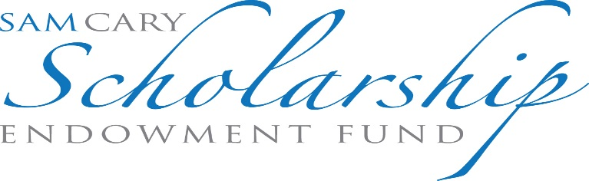
APPLICATION FOR SCHOLARSHIP
THIS SCHOLARSHIP IS OPEN TO ALL SECOND, THIRD AND FOURTH YEAR LAW STUDENTS AT THE UNIVERSITY OF COLORADO AND UNIVERSITY OF DENVER LAW SCHOOLS. ALL STUDENTS SHOULD APPLY REGARDLESS OF FINANCIAL NEED.

Name: ______________________________________________________________________
Address: ____________________________________________________________________
Telephone Numbers: Day: __________________
SECTION I - ACADEMIC ACHIEVEMENT
Please list all law schools at which you have ever been enrolled as a student:
LAW SCHOOL & DATES ATTENDED
________________________________________________
A current copy of your law school transcript must be submitted with this application.
Please list all other colleges and universities at which you have ever been enrolled as a student indicating the dates of attendance, major field of study and degree(s) received:
SCHOOL DATE MAJOR DEGREE
____________________________________________________________________________
____________________________________________________________________________
____________________________________________________________________________

Please list any academic honors or awards that you have received since first enrolling in college, including honors or recognition received during undergraduate and postgraduate enrollment:
AWARD INSTITUTION DATE ____________________________________________________________________________________________________________________________________________________________ ____________________________________________________________________________________________________________________________________________________________
SECTION II - FINANCIAL NEED
Please list all employment that you currently have:
Sources of Income
EMPLOYER HOURS WORKED PER WEEK MONTHLY INCOME ____________________________________________________________________________________________________________________________________________________________ ______________________________________________________________________________
List of Assets
- What is the amount of your total current savings and investments, including savings, checking, mutual fund, money market, certificate of deposit, stock, bond and trust accounts of which you are a beneficiary? $____________________________________

- If you own real property or a business, what is its current market value? $____________

- What is the total amount of any outstanding mortgage or loan secured by the real property or business? $____________________________________________________

- What is the total amount of any scholarship(s) that you have or will receive during the current academic year? $__________________________________________________

- What is the total amount of any loan(s) that you have or will receive during the current academic year? $________________________________________________________

- What is the total amount of any gift or loan that you have or will receive from your parents or other relatives during the current academic year? $_____________________

- If you are married, what is your spouse’s monthly income? $______________________
Financial Liabilities
What is the total amount of tuition and student fees charged at your institution for the current academic year? $_____________________________________________________________
Please list the names and ages of all members of your household and all individuals for whom you are financially responsible: __________________________________________________
____________________________________________________________________________
Monthly Expenses
What are your monthly expenses for the following items?
Rent/Mortgage $__________
Food $__________
Utilities $__________
Clothing and Laundry $__________
Transportation $__________
Insurance $__________
Credit card payments $__________
Other loans $__________
Child support payments $__________
Medical expenses $__________
Other expenses: $__________
TOTAL MONTHLY EXPENSES $ __________
THE SAM CARY SCHOLARSHIP ENDOWMENT FUND APPLICATION
CURRENT COMMUNITY AND FUTURE SCBA INVOLVEMENT
Please describe what you will do, if selected, to further the mission of the Sam Cary Bar Association, as well as describing your past and current community service, law related extracurricular activities, and past and present personal accomplishments, in a separate typewritten response.
Please limit your essay to no more than 1,500 words. Essay should also be written in Times New Roman font and double-spaced.
The Sam Cary Scholarship Endowment Fund will award a minimum of two scholarships. Award of the scholarship will be given in two installments. The first installment will be at the Scholarship Award Gala on November 19, 2022. The second installment will be after the completion of your service project, which will be determined by the Sam Cary Bar Association. Attendance at the Gala is mandatory to receive the scholarship.
Applications and any attachments must be received by the SCSEF Board no later than 5:00 P.M. on Friday, October 15, 2022 at the following email address (please scan and attach all requested documents):

The Honorable Billy Stiggers
Aurora Municipal Court

bstigger@auroragov.org

